Technical Document

Web Design

Nadja Jovanovic 4.2B

Building this website wasn’t easy. I have never built a website before, so this was something entirely new for me. I decided to make a gaming blog website, basically a website where you can find the news of the gaming world, updates, reviews, and such.

I researched gaming websites, saw how most of them were built, like most of them used dark backgrounds with a pop of 1 brighter color, bulkier fonts etc. So, when creating my website, I wanted to incorporate that. Black and green are the main colors of my website, I made the logo white and bulky to contrast that.

I first created the navigation bar, which I used the example we did at school for help and linked all the buttons to the pages they are supposed to lead to, except the search bar which you can just type in, but nothing happens. I then started creating my home page which I used examples on the internet for help. I found an image and placed it at the back and made a button that will lead you straight to the Blog page with all the articles. With css, I made the button as well as the navigation bar buttons change colors when you hover over them. I also added my logo in the corner that, if pressed, leads you to the home page.

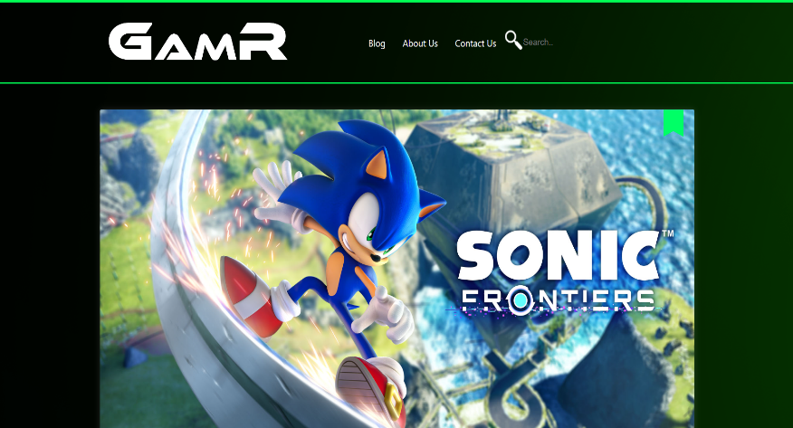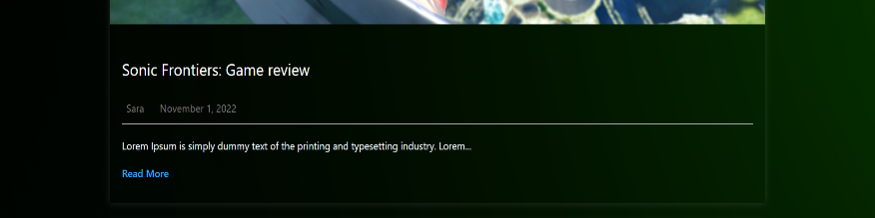

For my Blog page I found a code I really liked on the internet and changed it to suit my website, I changed everything in css, made the arrangement better and got rid of the stuff I didn’t need etc. I made the Blog page scrollable with only 3 articles available to read at the moment. All the images will zoom in when you hover over them and each one leads you to a different article. I made one for Sonic, God of war and Stray. Each article shows a name, date, author and a short summery below with a read more button that leads to the article.

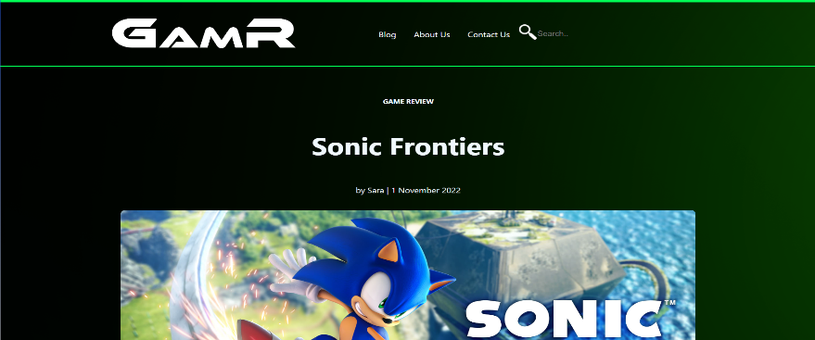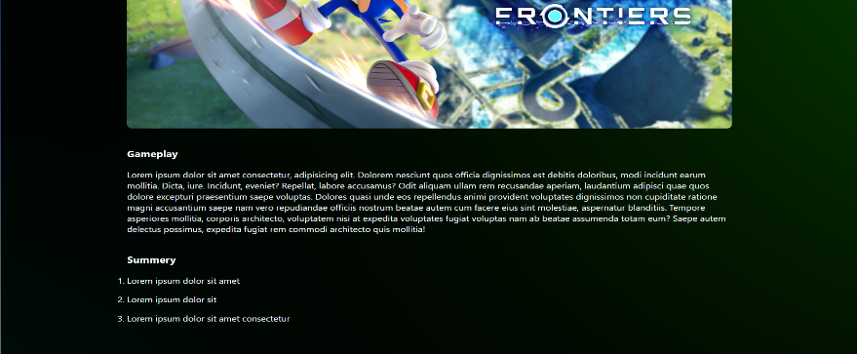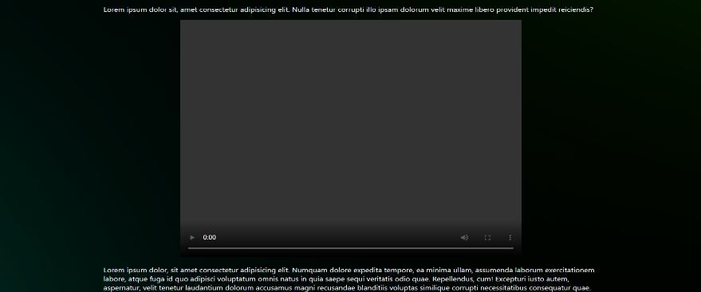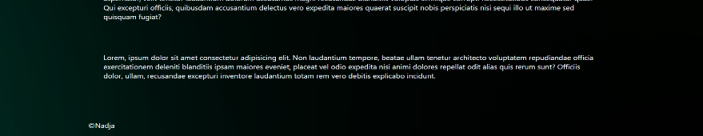

For my Article page I made a header with the Article title as well as a date and author below, than a picture of the game in question and the rest are just paragraphs. Below those I embedded a video trailer of the game and then some more text. For every video I went on YouTube and found a trailer of the game and then searched on the internet the code for embedding a video. Then I styled it in css, arranging it and correcting the size. Every article page is structured the same way but has their own picture and a related video. At the bottom of every page, in the footer, is my name.

For my About us page I just created a header with a title and then a text box containing the summery of GmaR. For the text I made use of Lorem and divided it into paragraphs, so it looks more realistic. Below that I made boxes containing pictures of people working for GmaR, gave them titles, a short summery, a fake email address and made a contact button which you can just press on, but it doesn’t do anything. In css I made the color change when the button is hovered as well as put shadows behind every box, so it stands out more.

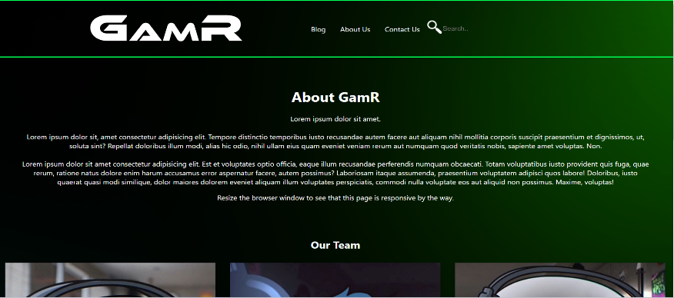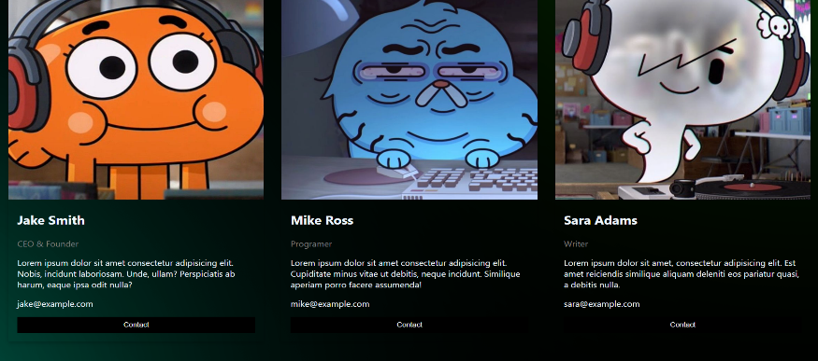

For the Contact Us page I found a code that suited my website on the internet and added it. I changed the css so the colors would match, added a hover feature, added a header, removed the background etc.

Usenet, or User Network, is a worldwide Internet based network for discussion system that consists of newsgroups that are organized by the subject. People can freely post their articles on there or send messages.

I would incorporate Usenet in my website so people can create their own accounts and have to log in before reading articles. Having individual users will help as each one can leave comments and discuss the games with each other on the website.

NewsGroup is a discussion about a particular subject consisting of notes written to a central internet site and spread trough UseNet. Usenet uses the Network News Transfer Protocol (NNTP).

I would incorporate NewsGroup to my website as a comment system so the users can communicate and leave comments under articles and leave their opinions and discuss. This would help the website as it would make audience engagement and let people express their opinions and not just read what the article says.